Step 1: Create a cluster and click on connect

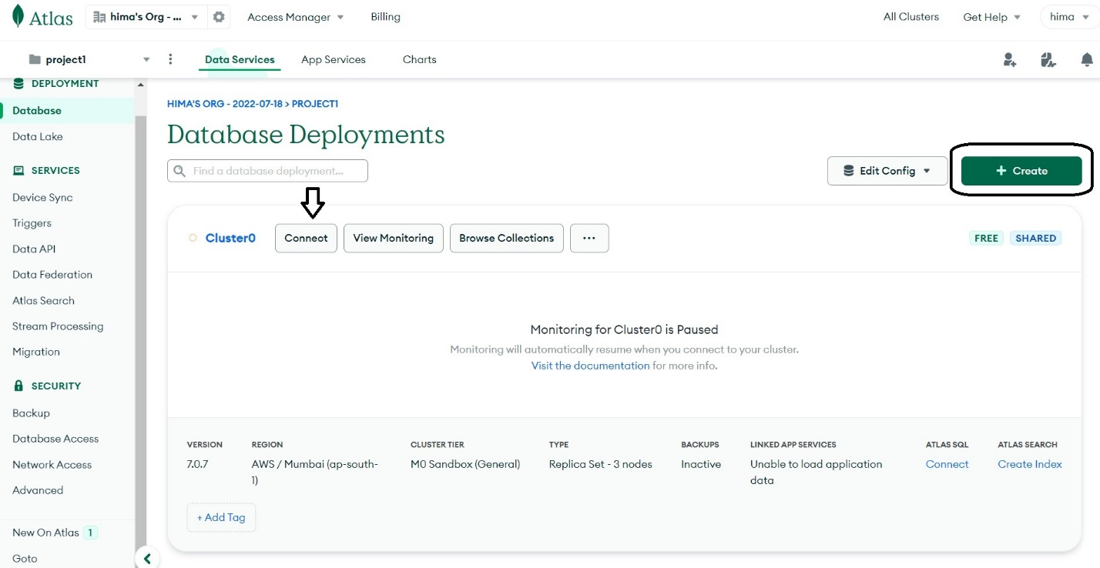

Step 2:after clicking on connect you will see the pop up like the given screenshot

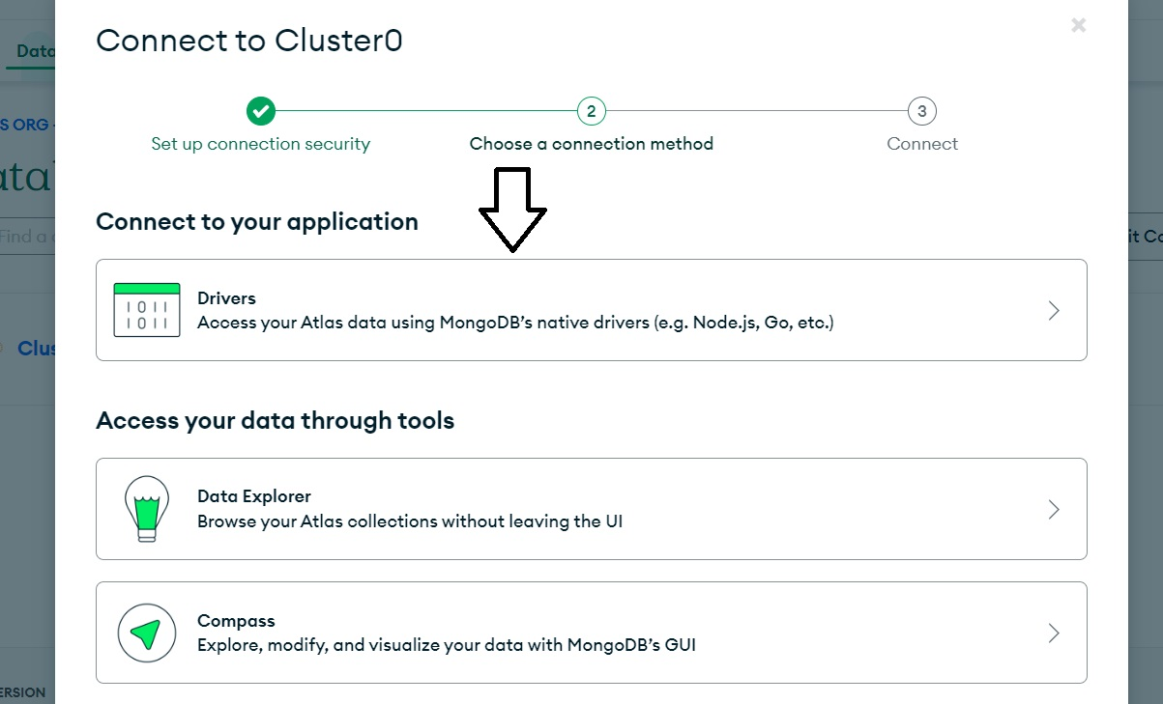

Click on the drivers .

Step 3:

After choosing drivers you will get a page like the below

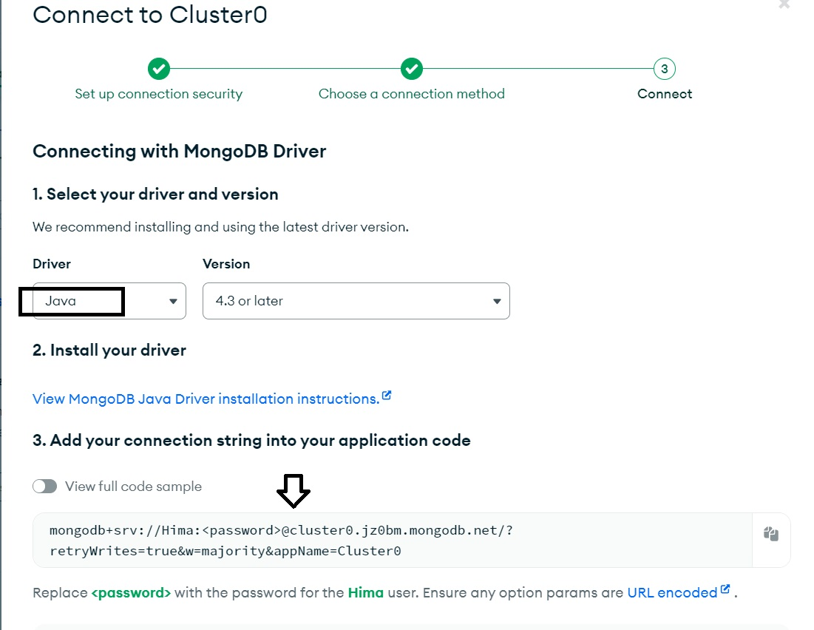

Choose java and its versions .

Copy the link and paste it in the application propertys of you spring boot application .

The network connection

First go to network access in the home page and then you can add ip address

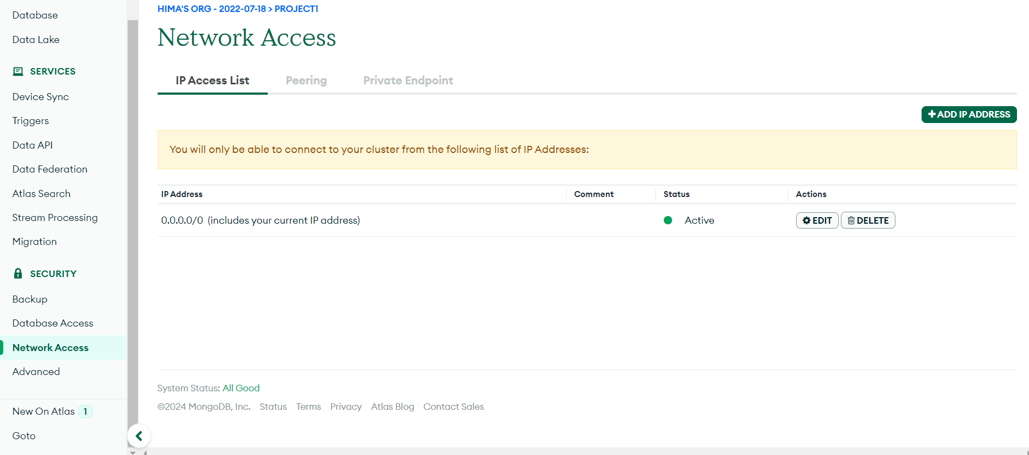

Database access

You can create a password

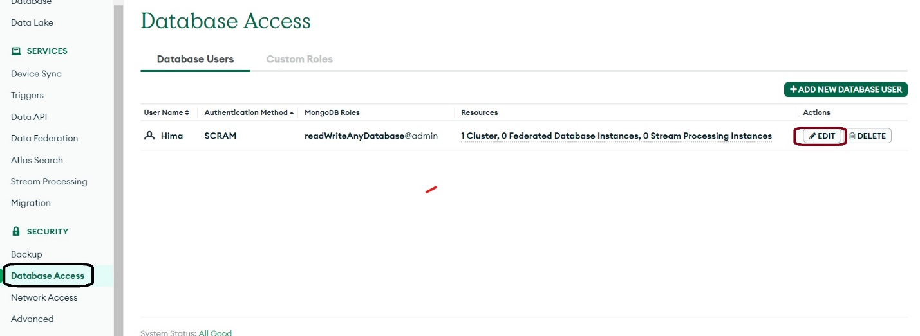

Use the password in the given url



For creating a database

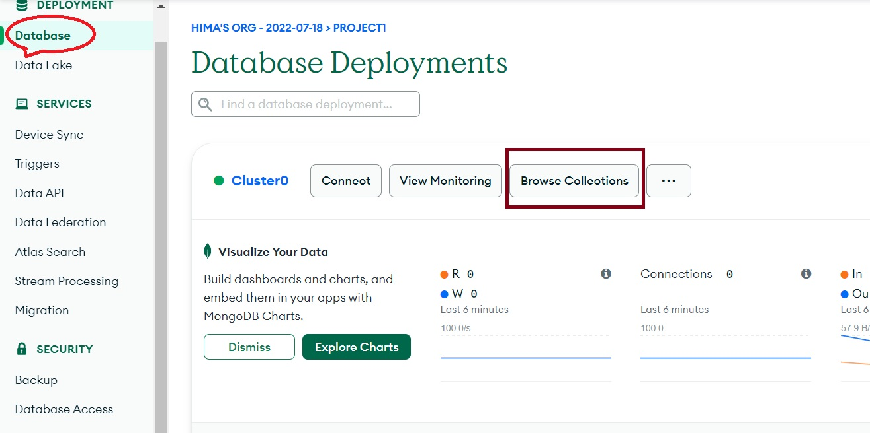

Create a database

